ECOLOGICAL GARDENING
What is ecological gardening?
Ecological gardening creates a system where nature works for and not against us.
Imagine a garden that never has pests, never needs digging, doesn’t need to be rested in winter, has no need for crop rotation, has virtually no weeds, needs very little water, and practically looks after itself.
To top all that off, this garden produces many times more than a traditional vegetable garden and regenerates itself year after year.
It sounds fantastic! How did you come up with this method?
My vegetable garden was no different to anybody else’s for many years. Some years I was keenly working in the garden and other years I ignored it. The years I ignored it still gave me results.
I began to think about why this was happening, the nature of plant relationships and how plant growth happens naturally in ecosystems. I started doing less in my garden, allowed nature to run the show, and it worked!

Surely it wasn't that easy.
I did make a few changes to how I approached gardening:
The first and probably most significant was squeezing far more plants into a given area than recommended.
The second change was to never dig the soil.
And third, I upgraded my composting system.
Once I did this, I noticed the garden taking on a life of its own. Weeds stopped appearing in the beds and plants started living much longer. The garden could endure longer periods without water, I was yielding far more than I ever had, and I could harvest every day of the year.
I wanted to know what was happening at a scientific level, so I applied my training as an environmental scientist to understand why I was getting these results. During this time, I had to completely let go of all my preconceived ideas as a gardener and look at the plot through the eyes of an ecologist.
I realized that I had created an ecosystem made up of edible plants, and it behaved in exactly the same way as a natural habitat.
I've heard it said that it's much better to follow what nature is telling you than to try to force a garden to go a certain way.
The wonderful thing about nature is that she works tirelessly, 24 hours a day, seven days a week. Nature follows very simple laws, and works in the same way everywhere in the world. When we create an ecological garden, her great stamina works in our favour.
So how does this work in at home?
Imagine a forest. A giant tree crashes to the ground after standing for hundreds of years. Such a large tree filled an enormous space, which is now empty.
Hundreds of dormant seeds of all kinds spring to life, desperately fighting for their opportunity to occupy the best real estate. The space that the tree left when it fell is quickly filled as these formerly dormant seeds become a diversity of larger plants, and harmony is restored.
Now when we look at the traditional home vegetable garden, what we see is a very unnatural system. There is very little diversity and a lot of empty space. Nature enforces her will on vegetable gardens in exactly the same way she does a forest, and this means that empty spaces will be filled as quickly as possible.
However, in a traditional vegetable garden there are no desirable seeds waiting to fill the spaces, so weeds fill them instead.
This makes sense! No wonder gardeners struggle with weeds all the time.
It is actually quite easy to have a weed-free vegetable garden. You simply do two things:
you avoid having empty spaces, and you make sure there is something desirable to fill spaces should they become available.
The result is a dense jungle-like planting arrangement that can yield an unbelievable amount.
The denseness also creates a highly protected micro-climate. This ideal growing environment causes your plants to last much longer. Greens don’t bolt as soon as a hot spell hits and cold sensitive plants are more protected as well.
Jungle-like planting? I wonder how city code enforcement would like that.
I have never heard anyone refer to ecological gardens as being unsightly or causing an issue with local authorities. The plots look different throughout the year, just like any vegetable garden, but each generally has a better plant cover at any given time. This tends to make ecological gardens look more attractive.
What about pests?
Pests generally locate their target plant species using sight or smell. Imagine how much more difficult it is to see your target plant when its outline is blurred by a sea of green. And how on earth could you smell your target plant when there are so many conflicting smells?
The dense mixed-up nature of ecological gardens creates a natural form of pest management.
But what about problems with mildew and plant diseases? I've always heard that you can avoid that by not planting closely.
People have asked this question a lot. However, there are thousands of
ecological gardens all over the world -- a significant number of these plots in areas of high humidity -- and nobody has reported this problem.
You mentioned that this is a more or less permanent planting. How does ecological gardening handle soil depletion?
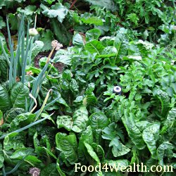
Crop rotation is practiced by dedicated gardeners for a very good reason. Different plants require different minerals from the soil and in different proportions. After an area has been planted with a certain species, the soil can be left depleted of certain minerals. To lessen the effects of this depletion, a different crop will be planted in the area the following year.
In addition, many gardeners rest their garden beds periodically and grow a green manure crop, usually a legume such as Lucerne [alfalfa] or field peas. These plants add nitrogen from the atmosphere through a process called nitrogen-fixing.
However, crop rotation and resting the soil isn’t necessary with ecological gardening because in a mixed-up planting arrangement, a single species doesn’t dominate a single area and deplete the soil.
Nitrogen is topped up in two ways: through planting edible legumes such as peas and beans within the garden, and by the addition of compost to the surface of any bare areas.
Who should start an ecological garden?
Absolutely everyone, from farmers to inner-city townhouse dwellers.
It may seem strange, but if you have never grown food before then you are in some ways at an advantage. Experienced gardeners may like to see themselves as adopting some ecological gardening techniques, but they find it difficult to let go of the need to control the system.
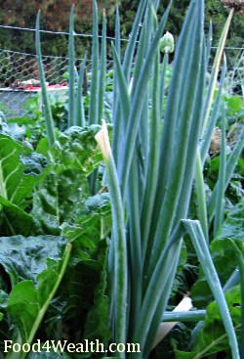
Like all industries, the gardening industry can get stuck in doing things a certain way and most seasoned gardeners will inevitably over-work the soil.
As a species, human beings prospered when we learnt to cultivate food using tilling and other traditional agricultural methods, so it’s difficult to turn back to nature. It might even feel like a step in the wrong direction.
But if we can let go of our need to control every living thing on the planet and start to work with nature, we actually gain more control by being able to grow food more efficiently.
So I take it you don't till. I don't either.
One of the first things I tell experienced gardeners is to throw away the hoe! Natural ecosystems like forests and jungles have never required gardeners with shovels, tillers, and hoes to come along every season to turn the soil, and neither do ecological gardens.
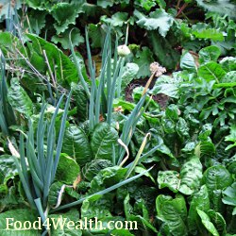
Digging soil upsets the soil structure which in turn reduces the soil’s ability to pass on valuable nutrients to plants. The loss of soil structure also reduces the soil’s ability to hold water.
Developing good soil structure is actually the best water conserving technique I know, and when practiced in conjunction with a dense planting arrangement creates a holistic soil ecology management plan. A dense planting arrangement will shade the soil's surface, which stops surface crusting, thus preventing runoff and nutrient depletion.
Good soil structure also allows soil organisms to do what they do best -- turn organic matter into available plant nutrients.
What should someone do that already has an established edible garden and wants to start ecological gardening?
Any existing vegetable garden can easily be converted into an ecological garden.
First, get your pathways laid out so that you never have to walk on your garden beds again. After that, get a good composting system going and apply compost to the soil surface. Then plant densely and diversely.

